


Selling Your Home
For All It’s Worth

Keller Williams Phoenix Realty
4862 E. Baseline Rd #103
Mesa, AZ 85206

Our Goal Today

- Get to know you better
- Answer all your questions
- Ask you important information

- Determine if we should be in the Real Estate Business together!

Many agents think their most important job is satisfying the customer.

We don’t think that’s true. We believe that satisfying the customer is simply the
minimum requirement for staying in business.

My staff and I work constantly to improve our systems, process, and services
to go beyond the standard level of “service” provided by most agents.

Simply put, our objectives are to get you the most money in the least time, and with as little stress as possible.
We want to provide the best service in the industry. Period.

Selecting the Best Realtor: Critical Criteria

 | Brett Tanner | AGT-X | AGT-Y
Is their marketing plan on the leading edge of technology? | 
Can they expose your property, in its best light, to every potential buyer? | 
Are they able to immediately answer inquiries on your property, even if the caller doesn’t leave contact information? | 
Do they offer both local and toll-free contact numbers for the convenience of potential buyers? | 
Do they guarantee that they will answer sign, ad, internet, brochure & flyer calls? | 
Do they do marketing 24/7 with a sign that gives easy access to their information? | 
Do they communicate effectively, and often? | 
Are they utilize Realtor.com, Zillow and Trulia with MILLIONs buyers ready to buy? | 
Do they syndicate your listing over 200 real estate related websites? | 
Do they contact all agents who have visited your home and request feedback on your property’s condition and pricing? | 
Do they have an internet accessible format with checklists for the entire real estate transaction? | 
Do they ensure that buyer’s interested in your home are QUALIFIED to purchase it? | 
Do they have professional resources only acquired through high-level relationships? | 
Have they successfully closed more than 1000 transactions? | 
Do they promote your listing to an extensive database of buyers & buyer investors? | 
Do they provide professionally produced materials to market your property to both agents and prospective buyers? | 
Do they a private website for you to view all activities associated with your listing and closing? | 
Do they focus on pricing and staging your home so that you can obtain “top dollar” in this market? | 
Do they have access to investors who may purchase your home and allow you to rent it back until you’ve found another one? | 

10 Questions Real Estate Agents HATE!

It’s important to know the track record of the Agent who is going to take care of one of your largest investments. Ask us and any other Realtor these questions to see who will do the most for you.

- Are you a Full-Time Professional or a part-time agent?
- Do you have a team to support your marketing activities and respond to our needs when you might be unavailable?
- Are your team members specifically trained for the tasks and responsibilities they manage?
- How do you rank within your local and national firm?
- What form and level of communication can I expect from you and your team and how often?
- What will you to do ensure that my property is shown, in its best light possible, to as many qualified buyers as you can every day?
- How many of your listings actually close escrow?
- Based on your recommending pricing, what do you think my home will actually sell for and how long will it take to sell?
- Will you be the one showing and selling my home?
- What makes you/your team different than the other agents in town?

Not only do we welcome these inquiries, we challenge you to ask them of anyone else regarding selling your home in today’s market!

Internet, Where We Market Your Home


Just a few of the websites we feature your home, with multiple photos and a virtual tour, whenever available.

Why should we list our home for sale with you?

You should hire us for the same reason that thousands of sellers have used us over and over again for years. They know that they can depend on us to get them the most money in the shortest amount of time with little risk.

Our No Risk Listing offers benefits that the ordinary agent does not. Our program offers flexible commissions to put more money in your pocket, a client reward program when both buying and selling that actually rebates cash back to you, a cancel anytime policy, and the right to sell your home yourself and pay us nothing. Additionally, our average time to sell a home is over 2.5 times faster than the average agent in our marketplace.

Every year we help hundreds of people buy and sell. The average agent handles around eight sales a year. When hiring a professional, experience should weigh heavily in that decision. Do you want to be the surgeon’s first patient?

Our most important program benefit is that we allow you to cancel the listing at anytime. Most agents will not give the consumer this right. You might ask yourself why agents need to “lock you up” for four to six months. Why would they be afraid to give you the right to cancel? Our philosophy is that we would rather strive to earn your business every day. WE are confident that we can provide a superior level of service and care. If we don’t, we don’t deserve your business. It’s that simple.

41.7% of Homes EXPIRE
…The First Time on the Market

In our ever-changing Real Estate market, experience counts for everything! Pricing your home correctly is the best advantage you can give yourself. The truth is that pricing your home property IN THE BEGINNING will maximize your return in the shortest time possible.

In any market, balancing Price with the Location, Condition and current Market for your property is critical. As a Seller, you only have control over two of these items, Condition and Price. Sharing how these four factors work together to maximize your top dollar is our specialty! We study the market daily to help advise our clients to make the best decisions, opt for the most effective improvements and set the best price that will attract the most potential buyers in the shortest amount of time possible. We focus on the results!



The Dangers of Not Starting at the Right Price
Is my home invisible in the market?

Your home has been on the market several months. You’ve seen several homes in the neighborhood sell. There is seemingly no interest in your home and you still have yet to get your first showing. Your agent has shown you the marketing that is being done and there is no doubt that your home has become invisible to any buyers that might be looking for a home in your area with the style and features that your home provides.

What buyers might have been presented the home through their buyer’s agent have lost all interest in the home because it has been on the market for a long period of time. In order to gain the attention of the buyers again, the price will need to be reduced. You must lower the price below what the market would have been several months ago, and now you need to price your home for even less.

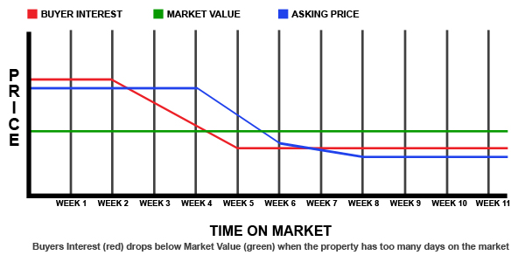

With the majority of buyers starting their search for their next home on the Internet, it is very important, now more than ever, to start your home’s pricing exactly where it should be when you begin marketing the home. Your buyers are looking in your neighborhood, but are only looking at the homes they can afford. If your home is priced outside their search, your home is invisible to the buyers and you will see your neighbor’s home sell long before yours does.

The Importance of Intelligent Pricing

As the triangle graph illustrates, more buyers purchase their properties at market value than above market value. If you price your property at market value, you are exposing it to a much greater percentage of prospective buyers and you are increasing your opportunity for a sale.
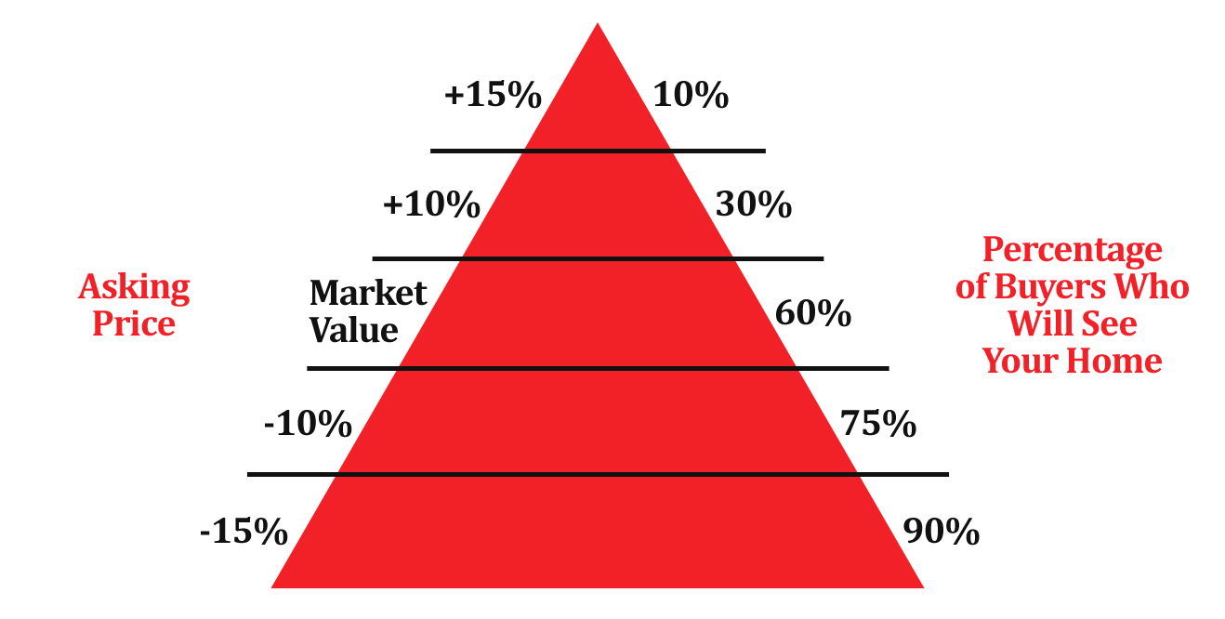

The Difference Between
Selling and SOLD

- Assist you in pricing your home correctly for this market

- 24/7 marketing both onsite and online

- Actively prospect for buyers for your home

- Professional marketing materials

- Help you stage your home and get it ready for market

- Negotiate the best terms possible for today’s conditions

- Communicate with you so you always know what’s going on

- Excite other Realtors to Show your Home

Marketing Strategy

The proper balance of these factors will expedite your sale.

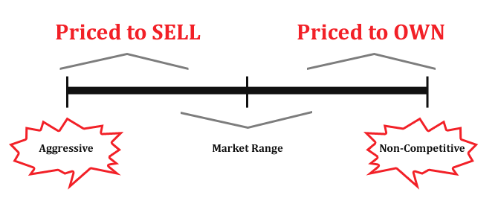
The market determines value... YOU determine how to compete.
Strategic Price Points

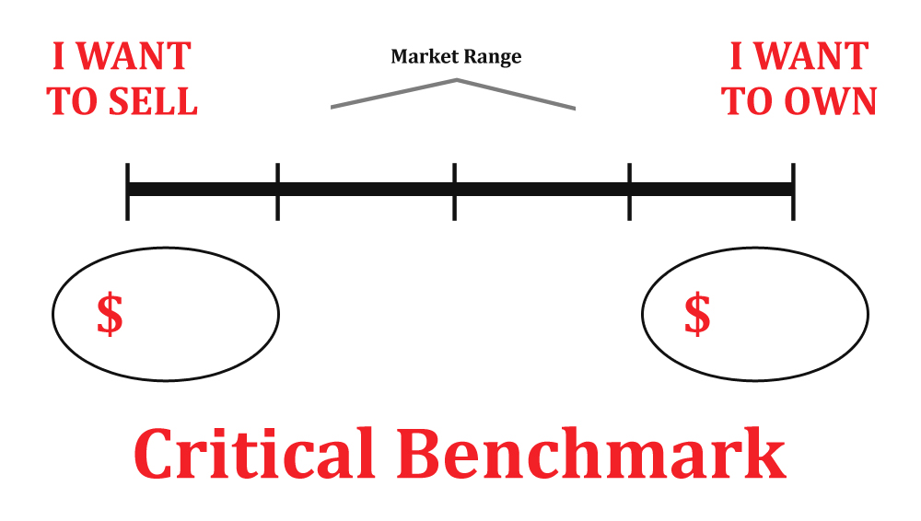

30 Days = 7 Qualified Showings

The No Risk Listing Agreement

Our negotiating skills net you more than the industry standard. That works out to be an additional bonus on the average home sale! The No Risk Listing Agreement gives you complete flexibility.

5%
1%
6%
0%
Brett Tanner Team Finds the Buyer
The BTHST Marketing Plan
Direct access to a large database of Buyers
We Negotiate
We Write the Contract
We Close the Transaction

You Find the Buyer
We Negotiate
We Write the Contract
We Close the Transaction

Another Agent Represents the Buyer
The BTHST Marketing Plan
Direct access to a large database of Buyers
We Negotiate
We Write the Contract
We Close the Transaction

You Find the Buyer Without Direct Help
For Sale by Owner Program
You Need No Further Assistance

Brett Tanner vs Other Realtors

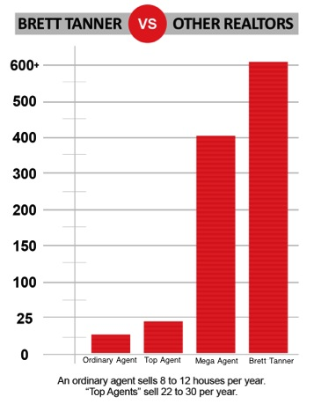

Why do your homes sell so fast? Do you price them too low?

Absolutely not. Most of our listings sell at or close to full price. We make it our business to know the market, so we can ensure we get the highest possible price for our sellers. Studies show that the highest value for a home is achieved in the first 20 days – so it is important to get it right the first time.

Our homes typically sell two and a half times faster than the average agent because of the effective marketing we do. We accomplish this by first doing a supply/demand analysis in the immediate area for any home we consider marketing. All agents have access to the same market information.

It is the evaluation of what that information means to the marketing of a home that matters. X-rays mean nothing until they are evaluated by a competent doctor. Similarly, knowing what the market is doing in any area affects both the marketing time and value.

The Listing Agreement Question

If you are not satisfied with our efforts to market your property and promote your interests, we will unconditionally cancel your listing contract.



Can you cancel anytime? YES
Our goal is your satisfaction!

Is Unhappy a Reason? YES
Our goal is your satisfaction! (Although we doubt this will ever be an issue)

Is it Easy? YES
Our goal is your satisfaction! Just let us know in writing.

In our listing contracts are the terms under which we will sever our relationship with a client. We want to simplify things and say again, our goal is your satisfaction. If you are not satisfied with our efforts to market your property and promote your interests, we will unconditionally cancel your listing contract*.

Sellers seek our services because we get the job done! We know how to market your home, find the buyer close the transaction. Most sellers know price is what you pay, value is what you get. I am confident you will be happy with my service and results. I always stand behind my service.

*A conditional release with the commission payable if sold during the original listing contract. These conditions are contained in the original listing contract and Cancellation Addendum to Listing Agreement. Please allow a 3 day lock Box and Sign Removal.

Selling Your Home

For All It’s Worth

Keller Williams Phoenix Realty
4862 E. Baseline Rd #103
Mesa, AZ 85206

